East Somerset Scout District
District Camping Competition

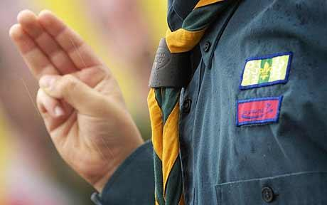 | 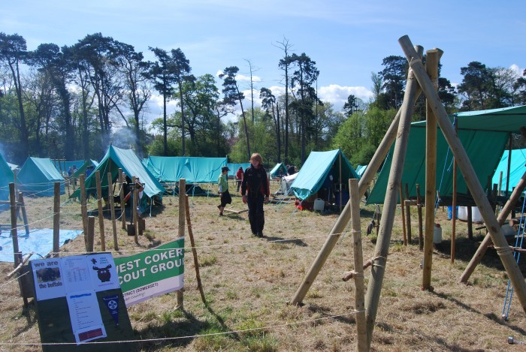
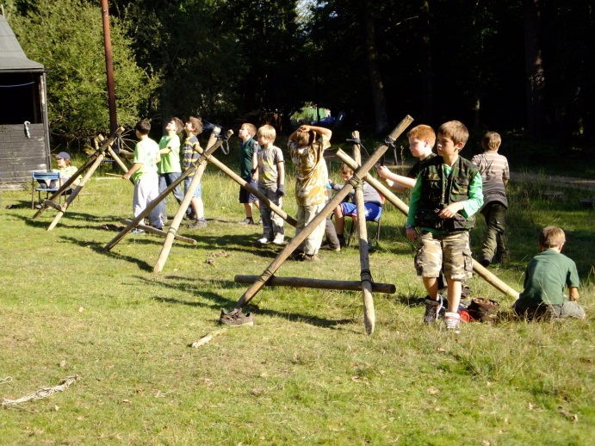 | 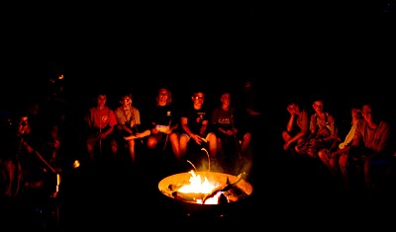
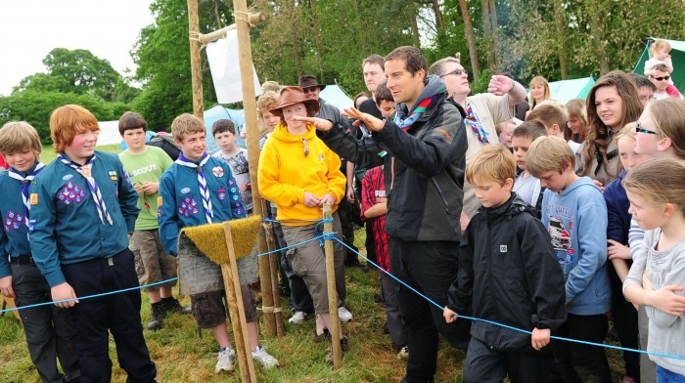 | 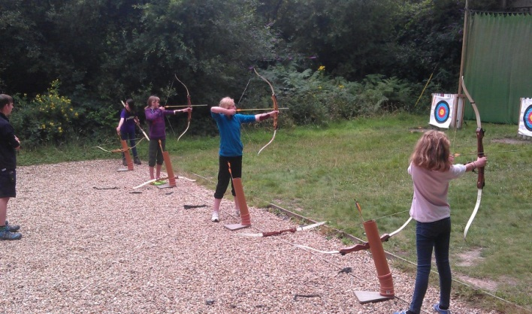

Date: Friday 15th May – Sunday 17th May 2026

Venue: West Woodlands Showground, Bunns Ln, Frome BA11 5ES
(Directions Later in Paperwork)

Cost: £17.50 per person

Closing Date: Monday 4th May 2026 [Spring Bank Holiday Monday]

Introduction

The District Camping Competition is open to all Scouts from across the East Somerset District. The Camp is not just open for experienced competition campers; we would like to see all new-comers and inexperienced Scouts come along to the camp and take part as Novice patrol to use the event as an educational but fun experience. Although a camping competition, the District sees this camp as an educational tool for both Scouts and Leaders to learn new skills and grow their Scouting knowledge and education. The camp is not all hard work; there will be a number of fun activities and entertainment included within the busy programme of the events.

The Competitions within the camping event!

Within the Camping Competition, the patrols of between 4 – 7 Scouts, will camp as a patrol on a site measuring 11 by 15 meters within small sub camps. These sub camps will be supported and managed by experienced camping competition markers. The sub camp teams will be not only to mark the patrols over the course of the weekend but also help educate, train and support all the patrols to reach the highest scores they can.

Competitions
Standard Competition
The competition campers will work as a team, preparing their own meal, developing their site and building gadgets to support their camping needs.

The competition and novice campers will work to a progressive mark system that will gradually increase over the course of the weekend through their own group preparation prior to camp and from the guidance of the sub camp teams giving advice and feedback from the regular inspections.

Rules:
- Site = 11x15m (with the gate on the shorter side – facing the central sub camp walkway)
- Minimum size of patrol = 4, maximum size = 7.
- All patrols must provide their own gadget wood (stored within their site from the start of camp).
- All cooking will be done on alter fire or gas.
- Each patrol must have a fire bucket filled with either water or sand on their site.
- The judges’ decision is final.
- Before departure on Sunday all sites must be checked by a member of the sub camp team.
- It is recommended that the Patrol has no more than 2 PL’s or APL’s and has a good range of mixed abilities and ages. However, to compete in the ‘Competition’ element of the camp we are not putting any restrictions of age or role – just the leaders’ recommendation that they are an EXPERIENCED PATROL capable of competing in this competition. (Remember the camp is about education and troop progression as well as the competitive side of camping competition).

Novice Competition
The novice competition although a competition, has been set up to provide inexperienced teams with the opportunity to try, learn and progress their knowledge of competition camping. Extra support will be given from the sub camp teams to these groups in particular to help motivate, teach and direct the Scouts to the next level of competition camping.

- A novice patrol is a patrol that is INEXPERIENCED in camping competitions and scouting skills. There are no restrictions – it down to the leader’s opinion and of course this will be assessed during the weekend by the sub camp teams.

Non-Competition ‘Green’ Patrols
The Green Patrols were a new addition in 2022. These are set up to provide teams with the opportunity to try, learn and progress their knowledge of competition camping *with Leader Onsite Support*. The sub camp teams will not be helping these groups so these teams can only be entered if they are accompanied by one experienced Leader/Adult. This person should help motivate, teach and direct the Scouts to the next level of Novice camping.

- A Green Patrol is a patrol that is NON COMPETITION and VERY INEXPERIENCED in camping competitions and scouting skills. There are no restrictions.
- A Green Patrol can request to be marked by the sub camp teams as a ‘practice’ marking, during the weekend, in discussion with the sub camp chief and subject to time availability.

The sub camp teams may assess the patrols over the course of the weekend to either promote Novice teams to Competition standard or vice versa dependent on the patrol’s ability and competency.
Please see competition mark sheet.
Camp Cooking Competition (Saturday 4pm – 6.30pm)

- Open to Competition and Novice Teams. Green Patrols can request to be judged but cannot enter the competition due to the high level of adult support.
- Each patrol has a budget of up to £4.00 per Scout for their chosen meal. Competition held on Saturday
(4 – 6.30pm).
- Receipts will need to be shown to the judges as part of the marking process.
- The Scouts will have 2.5 hours to prepare, cook and serve their chosen Main Meal for the judging panel. Starter/Dessert are optional.
- Any cooking must be done on the fire (unless permission is granted by the judges / sub camp team).
- Teams will be marked on hygiene, ability, cleanliness and of course the final meal (See mark sheet).

Gate Building Competition

- Judging of the gate competition will be completed by the external Gold judge coming in to mark the final positions on the Sunday. The Gate competition is only open to the competition & novice campers (not troop camp) and will be judged on structure, traditional lashings, design, originality and imagination (See mark sheet).
- Open to Competition and Novice Teams. Green Patrols can request to be judged but cannot enter the competition due to the high level of adult support.

The top 4 competition camp teams & top 2 novice camping patrols at the end of camp will receive District Trophies (the District Banner being first place).

Troop Camping

For those groups unsure about what is expected of them on a competition camp, we are offering troop camping at this event. Troop camping (camping as a group with your own leadership team) provides you as a leader with the opportunity to introduce and showcase the competition camp to your Scouts with throwing them in the deep end. The Troop campers will get the opportunity to visit the competition camp site through tours with the sub camp teams as well as get involved in the activities, entertainment and take part in their own troop camp competition.

The troop camp competition is a ‘Pioneering’ competition. On the Sunday, the camp chief will tell the troop campers what the challenge will be. The troop campers can then decide to either do it as a whole group or split up the troop camping into smaller teams. The theme is always something challenging enough but not too big to overwhelm the Scouts.

Please note that we would recommend, if equipment and Leadership availability allows, considering whether it is better to enter a Green Patrol or Troop Camp, not both. Please feel free to discuss this with anyone from the District Team.

Activities & Entertainment

The main focus of the weekend is the camping competitions but with any hard working activities, young people need to be able to have some down time. Some activities will be running throughout the weekend (times will be displayed on the camp notice boards) for the Scouts to take part in and have some down time. This also provides the sub camps with time to mark sites without Scouts around.

These include (subject to confirmation):
- Archery  - Cooking Activity  - Campfire | - Shooting (Any scouts participating must have a completed shooting permission form).

Leaders Attending Camp

Each year we have a number of group and District leaders come along and participate in the camp. We continue to welcome this but with our District growing and the need for more resources to run such a camp, we would like to ask all leaders attending for a few hours of their time to assist with various operational and activity needs (from running activities such as the Troop Pioneering Competition to supporting Campfire). If you are attending and you can offer some time, please contact Charlotte Redfearn-Ward to offer your support. Please feel free to come and visit the sub camp teams and ask questions. We (as Sub Camp Teams & District Staff) are more than happy to explain the marking system and what we are marking the Scouts on, teach Leaders on simple techniques in competition camping and to educate new Scouters in basic skills.

Explorers / Young Leaders: Are welcome to come on the camp but they will be expected to help run or assist with programming or support the group camping (if camping within the troop camp) rather than see this as an activity camp.

Catering for Leaders: Please note that Central Catering WILL be available for any Leaders and Activity Instructors over the weekend at £12 total. This can be costed for just some of the meals if requested. Talk to Red or Jo to book your catering space and pay direct (not with your Troop).

Example Patrol Kit List for Competition Camping:

- Sleeping Tents / guy ropes / dollies & Ground Sheet  - Store Tent  - Dinning Shelter  - Fire Bucket / Fire Beater  - Pioneering Poles / Gadget Good  - Pegs (wooden) & Mallets  - Rope / Sisal  - Cooking Equipment | - Water Containers  - Tarpaulin / sheet for Chopping Area  - Altar Fire  - Gas Stove / Gas  - Cutlery & Utensils  - Plates, cups, bowls  - Billies & dixies / frying pan / wok  - Cool Boxes | - Notice Board (with competed patrol information / menu)  - Bin bags  - Signs  - Axe & Guard  - Saw & Guard  - Tables & Benches

This is only an example list to help group prepare the camp. Some groups may wish to bring more or less equipment to camp to meet the needs of their patrol camping teams.

Map of Campsite

Closest Postcode: West Woodlands Showground, Bunns Ln, Frome BA11 5ES
Please note that parking is likely to be on the field with access from the Bunns Lane entrance TBC. Please do not block access.

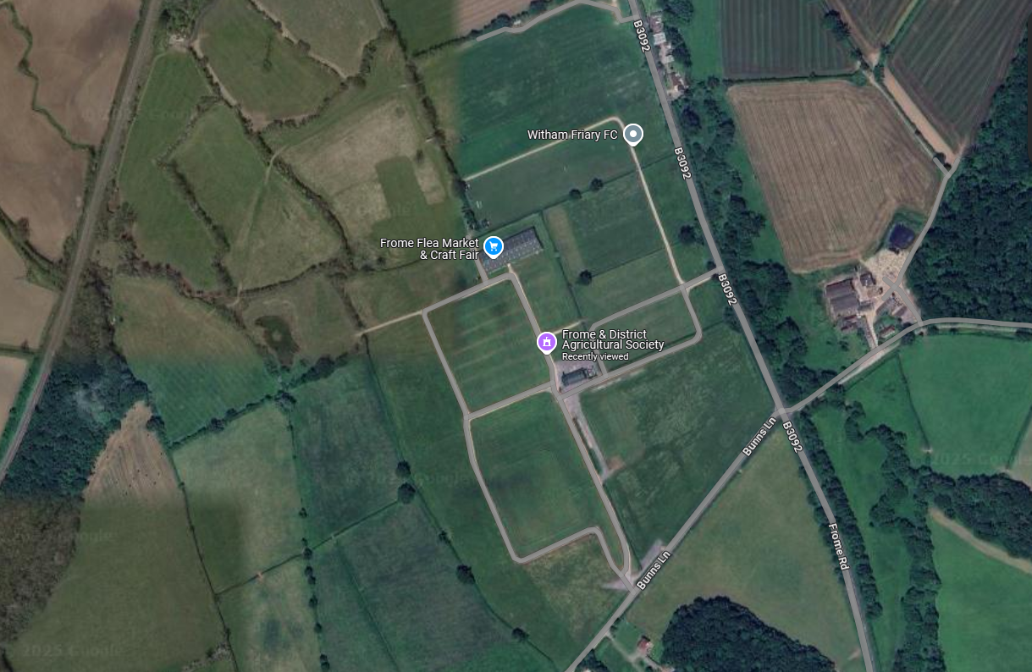

Paperwork Required:

Paperwork | What is needed?
NAN Form | Please make sure you have completed the online NAN form prior to camp. To access this form visit: scouts.org
Health Forms  (Scout & Adult Attendees) | Every adult and young person must complete a health form prior to camp. Please make sure that these forms (attached in the pack) are completed in full and sent with the application form & payment.
Booking Form &  Payment | Please make sure you have completed a booking form (attached) for EACH TEAM and any Troop Camp. Please make sure group cheques are used for payment.
Home Contact /  In Touch | Please make sure that you have arranged a Home Contact / In Touch contact prior to camp and that you have told us who they are on your application form.
Mark / Feedback Sheets (for your reference only) | All the mark sheets are attached within this pack. These will help you understand what the young people will be marked against. For troop campers you may want to print these out yourself and use for a mini inspect of tents yourself, getting the Scouts used to the marking system.
Shooting Permission Form | All young people under the age of 18yrs of age will be required to complete a shooting form before they will be able to take part in the air rifle shooting activities on camp (see attached paperwork).

Return paperwork and payment to:
Charlotte Redfearn-Ward, East Somerset Camping Competition, Base Camp, 26 Drake Road, Yeovil, Somerset, BA21 5EY ADCscouts@eastsomersetscouts.org.uk

Timetable

Friday
5pm | Site open for groups / patrols (competition starts) – see sub camp team for allocated site.
9pm | PL / APL Council (with sub camp teams) – in main sub camp tents  Rules / expectations / timetables / safety / site information
9pm | Leaders Meeting (including troop campers leaders) – expectation & rules for camp – located in the main marquee/central location.
10pm | Lights Out

Saturday
6.30am | (no banging of pegs or boundary poles before this time)
9am | Flag break (meet at central flag location)
10.30 – 11:30am | Unmarked Inspection – Guidance and Initial Advice, no marks but will include feedback sheet
12pm | Lunch
1pm – 3pm | First Marked inspection (sub camps)  Activities will run until 4pm
4pm – 6.30pm | Cooking competition (preparation / cook / serve) – please make sure that sub camp teams are aware of group participating in this competition (No preparation to start before 4pm).
7pm - 8.30pm | Second Marked inspection (sub camps)  Camp fire entertainment.
9.30pm | PL / APL council (with sub camp teams) in main sub camp tents.  Leaders meeting – located in the main marquee/central location.
10pm | Lights Out

Sunday
6.30am | (no banging of pegs or boundary poles before this time)
9am | Flag (meet at central flag location) – Thought for Day / Scouts Own
10am – 12pm | Third Marked inspection (Sub camps) / Activities Start  Troop camp competition: Activity for event given at flag break.
12pm | Lunch
12.30pm | Gold / final inspections from external camp judge
2pm | Flag down & awards presented (Please do not take down any of the sites until after flag down and award presentation).

 | East Somerset District Scout  Camping Competition 2026  Friday 15th May – Sunday 17th May 2026  (Camp open from 5pm for competitors on the Friday night)

Competition / Novice / Green Camping Competition Teams Registration:
Complete one of these forms per patrol entered!

Troop Name:

Patrol Name: :

Please Circle or Delete as appropriate: Green / Novice / Competition

Name of Young people within the Patrol: | Gender: | Date of Birth:
PL:
APL:
QM:

Leaders Name: |  | Contact details while on camp:

Home contact / In touch Contact & Address: |  | In Touch Contact details:

Fee’s: £17.50 per young person camping: | Total cost:
£17.50 x …………………….. | £

Cheques made payable to: ‘East Somerset District Scout Council’ or by BACS to:
Lloyds Bank: Sort Code 30-99-98 Account 32500260 ‘East Somerset District Scouts – Events’
Please ensure you reference your GROUP and the EVENT and let me know you’ve paid by BACS.
I enclose the full payment and a health form for each young person and adult attending the camp.

Leaders Signature: |  | Date:
 | East Somerset District Scout  Camping Competition 2026  Friday 15th May – Sunday 17th May 2026  (Camp open from 5pm for competitors on the Friday night)

Troop Camping Teams Registration Form:

Troop Name:

How many young people have you got attending: | Numbers:
Scouts (£17.50pp)
Young Leaders / Explorers: (FREE)
Adult Helpers / Leaders: (FREE)
Leaders Family Members: (FREE)
Total

Leaders Name: |  | Contact details while on camp:

Home contact / In touch Contact & Address: |  | In Touch Contact details:

Please indicated Yes or no for competition entry & how many teams:
Cooking Competition: | Troop Camp Challenge:  (Mini Pioneering)

Please remember any troop campers wishing to take part in the cooking competition will need to bring their own tables and cooking equipment (including alter fire) to the cooking competition area on the sub camp. Troop campers will also need rope / sisal & some gadget wood for troop camp challenge.

Fee’s: £17.50 per young person camping / Adults & Young leaders Free: | Total cost:
£17.50 x …………………….. = | £
Total | £

Cheques made payable to: ‘East Somerset District Scout Council’ or by BACS to:
Lloyds Bank: Sort Code 30-99-98 Account 32500260 ‘East Somerset District Scouts – Events’
Please ensure you reference your GROUP and the EVENT and let me know you’ve paid by BACS.
I enclose the full payment and a health form for each young person and adult attending the camp.

Leaders Signature: |  | Date:

Camping Competition:
Gate Competition Mark Sheet:

TROOP: |  |  | PATROL:

Gate Competition: | Max | Score
Design | 5
Structure (Safe / Strong) | 5
Standard of Traditional Lashing | 5
Originality | 5
Imagination | 5
Total | 25

Camping Competition:
Cooking Competition Mark Sheet:

Budget - £3.50 per Scout  Within budget, no unauthorised extras. | 5
Menu Content –  All menu requirements met, balanced courses, complexity, most original use of ingredients. | 20
Team Work -  Leadership, work allocation, planning. | 10
Food Preparation/Health and Safety -  Aspects of safe and hygienic practise, tidiness of work station, organisation and methods. Cleaning up after cooking. | 25
Timing –  All courses (if more than one) ready together, served together at correct temperature. Was the meal as planned on the menu. | 15
Serving –  Does the food look tempting, dish(es) suitable for service, do the course complement each other. | 25
The Tasting – Main  Seasoning, Texture, Flavour, colour. | 25
Total (125) | 125

Parental Consent Form – SHOOTING (District Camping Competition)

PLEASE NOTE: SPECIFIC PARENTAL PERMISSION IS NEEDED BEFORE A YOUNG PERSON CAN TAKE PART IN THIS EVENT.

Section:
I being the parent/guardian of this person named below declare that he/she is not subject to restriction by virtue of the regulations set out in section 21 of the firearms Act 1968 (extract printed overleaf and hereby give permission for:

……………………………………….
(Name of Young Person)

To take part in the Air rifle shooting

Proposed Activity: Air Rifle Shooting

Date: 16th – 17th May 2026

Place of event:
Frome Showground
(East Somerset Camping Competition)

Additional Information:

Please state if he has a disability or condition, which may be affected by this activity:

Leader(s):
Richard Slade & Kath Slade
Liam Burt
Dates to Include:
16th May 2026
17th May 2026

Please indicate details of any medical treatment they are receiving at the moment:

Contact details in the event of an emergency:

Telephone:
Mobile:
Address:

Signature:
Date:

Parent or Guardians consent:
BEFORE SIGNING PLEASE READ ATTACHED EXTRACTS PRINTED ON THE REVERSE OF THIS FORM

This is important information for parents to read prior to signing the shooting permission form.

Extracts from the Firearms Act 1968

Section 21

- A person who has been sentenced (to custody for life or) to
preventive detention, or to imprisonment or to corrective training for a term three years or more (or to youth custody or detention in a young offenders institution) for such a term, or who has been sentenced to be detained for such a term in a young offenders institution in Scotland, shell not at any time have a firearm or ammunition in his possession.

- A person who has been sentenced … to imprisonment for a term of three months or more but less than three years (or to youth custody or detention in a young offenders institution) for such a term, or who has been sentenced to be detained for such a term in a detention center or young offenders institution in Scotland, shall not at any time before the expiration of the period of five years from the date of his release have a firearm or ammunition in his possession.

This Means

Section 21 prohibits the possession of firearms and ammunition (under any circumstances) by any person who has been convicted of a crime and sentenced to a term of imprisonment (or its equivalent for young persons) of 3 months or more. The prohibition applies in all circumstances, including handling and firing at an approved shooting club or at a clay pigeon shoot where a certificate is not ordinarily required. It also applies to the possession or use of other categories of firearms and ammunition such as AIRGUNS or shot cartridges for which a certificate is not needed.

A sentence of 3 months to 3 years attracts a 5-year prohibition, shorter ones no prohibition but longer ones means a life ban

