East Somerset Scout District
JAWS Scout Activity Camp
 |  | 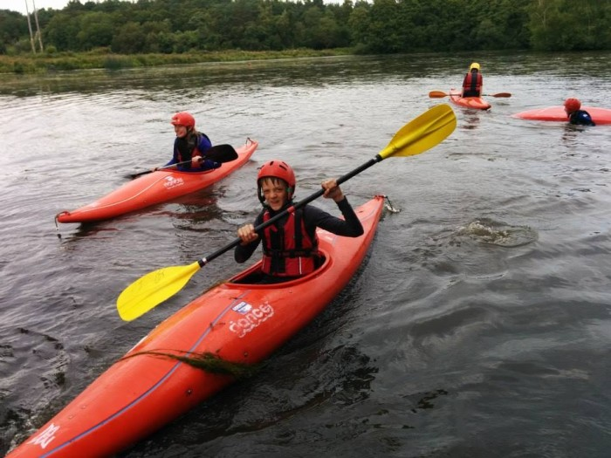
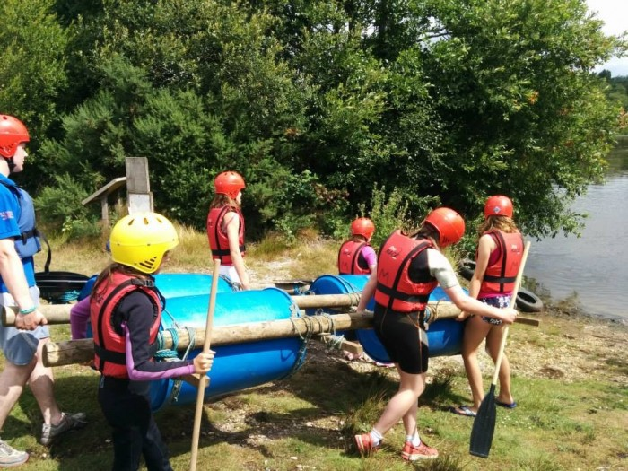 |  | 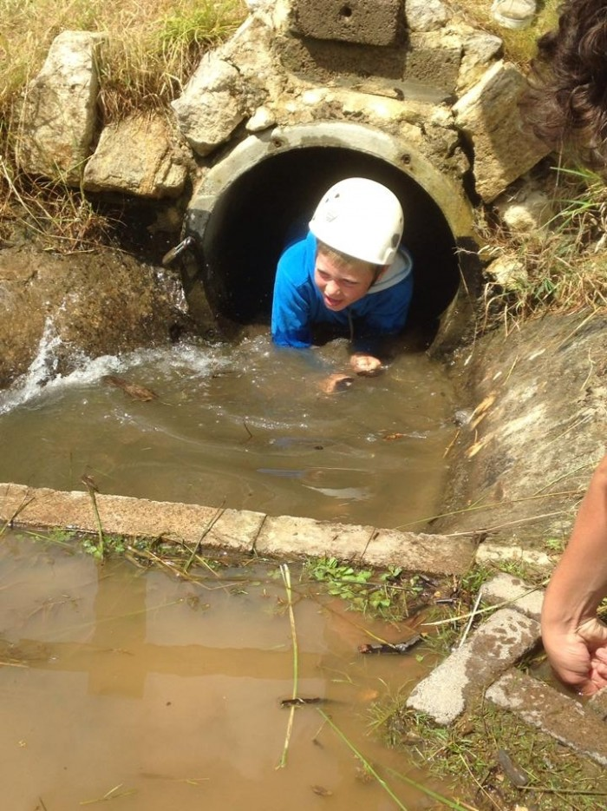
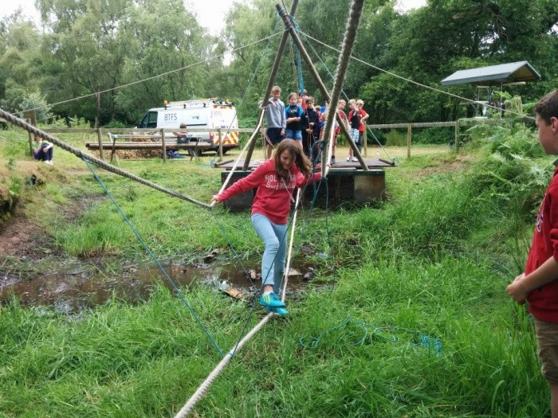 |  | 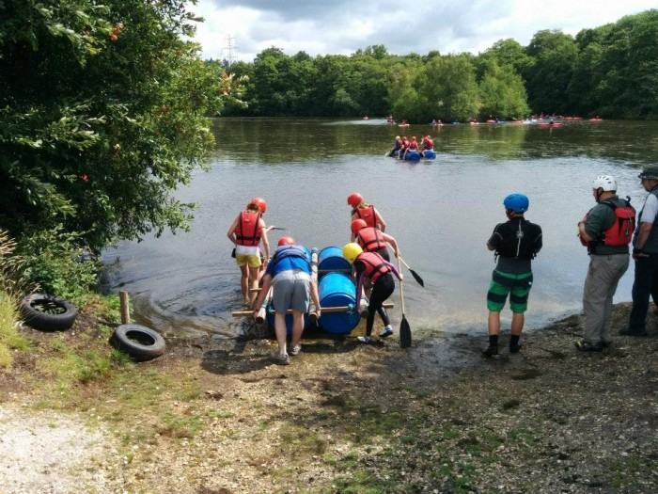
 | Date: Friday 3rd July to Sunday 5th July 2026  Venue: Buddens County Scout Campsite. Puddletown Road, Wareham BH20 7NU. (Site telephone number: 01929 472374)  Cost: £74.00 per Scout / £20.00 per Leader (District Cost)  Notification of Intent to Attend: Sunday 17th May 2026  Paperwork & Payment: Sunday 14th June 2026

Introduction

This year’s JAWS event is open to all Scouts across East Somerset District. All Troops will camp on the main camping field and will be required to cater for themselves as a group. We are going to ‘Buddens Activity Centre’, which is now owned by Rockley Watersports, and we will have access to all the facilities again, including the showers / toilet block, a site gift/tuck shop, climbing tower, pioneering, caving, air rifle shooting and water activities.

For site location visit: Buddens Activity Centre (rockley.org)

The timetable we run has increased to a maximum number of 192 Scouts. This should ensure that ALL scouts and troops that wish to attend can do within the increased numbers. So please let me you’re your intention and rough numbers by Sunday 17th May 2026 (end of Camping Competition weekend) and then submit paperwork by the deadline of Sunday 14th June 2026.

Overall permit holder for the event will be Charlotte Redfearn-Ward and a NAN form will need to be completed for each troop on the Scouts.org website page - please ensure you send the paperwork (summary forms not health forms) to Charlotte Redfearn-Ward. This must include medical info and photo permissions and should include all Scouts, YLs and Leaders camping on your troop site, including any activity instructors camping as part of your troop site.

Enclosed with this pack are health forms for Scouts (also for Young Leaders) and Adults that must be completed by all those on site, both camping and just visiting. Also enclosed is a shooting permission form which must be completed by anyone who wishes to take part in the shooting activity. Troops will be responsible for their own health forms and provision of first aid facilities and resources; you must also make your own arrangements for a ‘Home Contact’ and this info MUST be included on the reply slip. Also don’t forget to complete the included NAN form online at: http://www.scoutforms.org.uk/

Please note that Budden’s does not allow dogs.

Any parents/helpers that you wish to bring along to help must have DBS clearance through the Scout Association and will be required to pay the camping site fees only (£20).

Leaders: Provision is made for ONE FREE LEADER to every 12 Scouts (ie within Ratios). Leaders who are confirmed with me to be running Activities will be FREE. All other Leaders and Young Leaders will be counted as paying £20 camping fees. You may choose to recover these costs within the troop or group as opposed to charge leaders direct. If you want to check how much you will need to pay then I am happy to help calculate so you don’t over or under pay.

All Young Leaders within Scout Troops are welcome but they should be there to help like the adult helpers and leaders attending. They will require Module A Young Leader Training as a minimum. If there are spaces available during the activity session they will be allowed to take part but Scouts must take priority during the camp (hence the price difference).

We would like every troop to provide a land based activity for when the scouts are not on the water. This has worked very well in previous years with troops running activities such as a scavenger hunt, trading post, volleyball, as well as many others. Please let me know by the closing date. If there is a repeat in activities I will have to ask the second troop to change and bring something different so that there is plenty of variety.

If you would like any further information please feel free to contact me.


YIS, RED

Charlotte Redfearn-Ward
ADC Scouts
adcscouts@eastsomersetscouts.org.uk
Base Camp, 26 Drake Road, Yeovil, Somerset, BA21 5EY

 | East Somerset District Scout  JAWS ACTIVITY CAMP 2026  Friday 3rd July – Sunday 5th July 2026

Troop Name:

How many young people have you got attending: | Numbers:
Scouts: £74.00 per Scout
Leader (FOC x 1:12 Ratio) £0 per Leader
Young Leaders: £20.00 per YL
Adult Helpers / Leaders: £20.00 per Leader
Total NUMBERS:

Main Leaders Name: |  | Contact details while on camp:

Home contact / In touch Contact & Address: |  | In Touch Contact details:

OUR TROOP’S PLANNED LAND BASE ACTIVITY WILL BE:
Activity:

Fee’s | Total cost:
£74.00 (Scouts) x …………………….. =  £20.00 (YL’s / Leaders / Helpers) x …………………….. = | £  £
TOTAL COST | £

Cheques made payable to: ’East Somerset District Scout Council’
BACS to: Lloyds Bank: Sort Code 30-99-98 Account 32500260 ‘East Somerset District Scouts – Events’

Please ensure you reference your GROUP and the EVENT and let me know paid by BACS.

I enclose the full payment and a health form for each young person and adult attending the camp with this application. I understand that in the event of cancellation, full refunds may not be possible due to unrecoverable costs.

Leaders Signature: |  | Date:

Return to: Charlotte Redfearn-Ward, Base Camp, 26 Drake Road, Yeovil, Somerset, BA21 5EY

East Somerset District Scout
JAWS ACTIVITY CAMP 2026

Friday 3rd July – Sunday 5th July 2026

Troop Name:

SCOUT / YL / LEADER NAME | DOB | EMERGENCY CONTACT NAME | EMERGENCY CONTACT NUMBER | MEDICAL/DIETARY NOTES | PHOTO  Y/N | SWIM  Y/N

Consent Form – SHOOTING (JAWS ACTIVITY WEEKEND)

PLEASE NOTE: SPECIFIC PARENTAL PERMISSION IS NEEDED BEFORE A YOUNG PERSON CAN TAKE PART IN THIS EVENT.
Please ensure you complete all boxes, even if the answer is ‘No’ or ‘N/A’.

Group / Section:
I being the parent/guardian of this person named below declare that he/she is not subject to restriction by virtue of the regulations set out in section 21 of the firearms Act 1968 (extract printed overleaf and hereby give permission for:

……………………………………….
(Name of Young Person)

To take part in the Air rifle shooting

Proposed Activity: Air Rifle Shooting

Date: 3rd July – 5th July 2026

Place of event: Budden’s Activity Centre. Puddletown Road, Wareham BH20 7NU:
EAST SOMERSET JAWS CAMP.

Additional Information:

Please state if they have a disability or condition, which may be affected by this activity:

Leaders:
Richard & Kath Slade
Liam Burt
Date: 4th July & 5th July 2026

The National Small Bore Rifle Association

Reg. No: 09913
Please indicate details of any medical treatment they are receiving at the moment:

Contact details in the event of an emergency:

Telephone:
Mobile:
Address:

Signature:
Date:

Parent or Guardians consent:
BEFORE SIGNING PLEASE READ ATTACHED EXTRACTS PRINTED ON THE REVERSE OF THIS FORM

This is important information for parents to read prior to signing the shooting permission form.

Extracts from the Firearms Act 1968

Section 21

- A person who has been sentenced (to custody for life or) to
preventive detention, or to imprisonment or to corrective training for a term three years or more (or to youth custody or detention in a young offenders institution) for such a term, or who has been sentenced to be detained for such a term in a young offenders institution in Scotland, shell not at any time have a firearm or ammunition in his possession.

- A person who has been sentenced … to imprisonment for a term of three months or more but less than three years (or to youth custody or detention in a young offenders institution) for such a term, or who has been sentenced to be detained for such a term in a detention center or young offenders institution in Scotland, shall not at any time before the expiration of the period of five years from the date of his release have a firearm or ammunition in his possession.

This Means

Section 21 prohibits the possession of firearms and ammunition (under any circumstances) by any person who has been convicted of a crime and sentenced to a term of imprisonment (or its equivalent for young persons) of 3 months or more. The prohibition applies in all circumstances, including handling and firing at an approved shooting club or at a clay pigeon shoot where a certificate is not ordinarily required. It also applies to the possession or use of other categories of firearms and ammunition such as AIRGUNS or shot cartridges for which a certificate is not needed.

A sentence of 3 months to 3 years attracts a 5-year prohibition, shorter ones no prohibition but longer ones means a life ban

